Lesson 4 Demo 9: Create a Pod in a Sample Environment

This section will guide you to:

* Create a pod with in a sample environment

This lab has one sub-section, namely:

1. Creating a pod in a sample environment

**Note:** If you don’t have an existing Kubernetes cluster, refer to the Demo 1.1 of Lesson 1.

**Step 1:** Creating a pod in a sampleenvironment

* Start the kubernetes cluster in the lab
* Create a new yaml file as follows:

*cat > envars.yaml*

apiVersion: v1

kind: Pod

metadata:

name: envar-demo

labels:

purpose: demonstrate-envars

spec:

containers:

- name: envar-demo-container

image: gcr.io/google-samples/node-hello:1.0

env:

- name: DEMO_GREETING

value: "Hello from the environment"

- name: DEMO_FAREWELL

value: "Such a sweet sorrow"

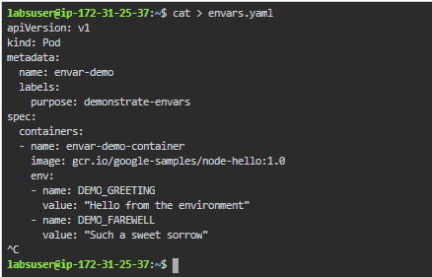

* Let’s create a pod based on the yaml configuration file using kubectl as shown below:

*kubectl apply -f envars.yaml*



* You can list the running pods using the command shown below:

*kubectl get pods -l purpose=demonstrate-envars*

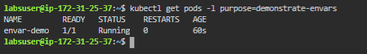

* Next, get a shell to the container running in your pod:

*kubectl exec -it envar-demo -- /bin/bash*

* Now, in the shell, run the **printenv** command to list the environment variables. You will be able to see the following output:

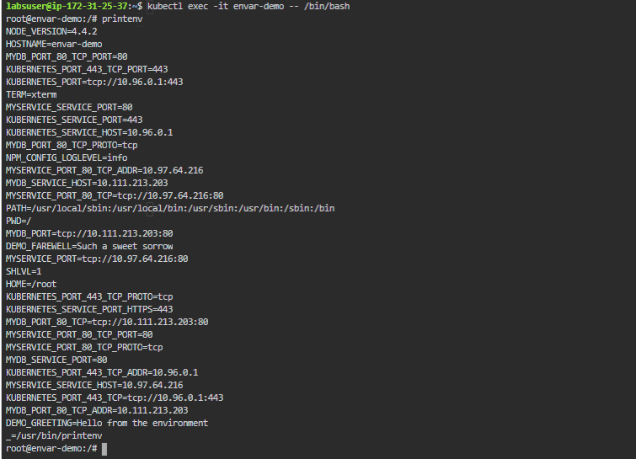

* Type the **exit** command to exit from the shell as shown below:

